FREQUENCY SPECTRUM.

WHY IT'S MEANINGFUL,
HOW TO USE IT IN GAINING INFORMATION
AND IT'S APPLICATION IN IMAGE PROCESSING

ID NUMBER: 201224180102
PREPARED BY: BAHROUN SALIM

Introduction
Signal processing is a method of extraction information from the signal which, in turn, depends upon the type of signal and the nature of information it carries. Thus signal processing is concerned with representing signals in mathematical form and extracting the information by carrying out algorithms. Mathematically signals can be represented in terms of basic functions in the domain of the original independent variable or it can be represented on terms of basic functions in a transformed domain. Similarly, the information contained in the signal can also be extracted either in the original domain or in the transformed domain.
What is Signal Frequency Spectrum
Any signal can be represented as an amplitude that varies with time. In the transformed domain it has a corresponding frequency spectrum. The frequency spectrum of a time-domain signal is a representation of that signal in the frequency domain. The frequency spectrum can be generated via a Fourier transform of the signal, and the resulting values are usually presented as amplitude and phase, both plotted versus frequency .Often, the frequency spectrum clearly shows harmonics, visible as distinct spikes or lines. Fourier
Depending on the periodic nature of a signal there are four distinct Fourier representations for it .Periodic signals have Fourier series representations whereas non-periodic signals have Fourier transform representations. The Fourier series corresponds to continuous time periodic signals whereas the discrete-time Fourier series corresponds to discrete-time periodic signals .Similarly , if the signal is non-periodic continuous time signal the representation is termed as Fourier – transform whereas of non-periodic discrete –time signal the representation is termed as discrete-time Fourier Transform .
TIME PROPERTY | Periodic | Non-Periodic
CONTINUOUS | Fourier Series | Fourier Transform
DISCRETE | Discrete-time Fourier Series | Discrete-time Fourier Transform
How to implement The Frequency Spectrum
From the mathematical Relationships of Fourier representation of signals, we have to draw the frequency spectrum as follows:
The Magnitude spectrum
Draw the magnitude of the signal after the transformation versus the frequency.
The Phase Spectrum
Draw the phase of the signal after the transformation versus the frequency. THE MAGNITUDE SPECTRUM AND The PHASE SPECTRUM ARE CALLED LINE SPECTRA.
The following example shows a signal and its corresponding spectra using Fourier series.
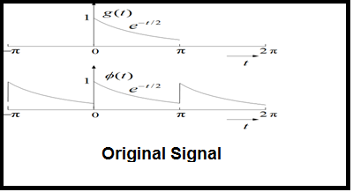

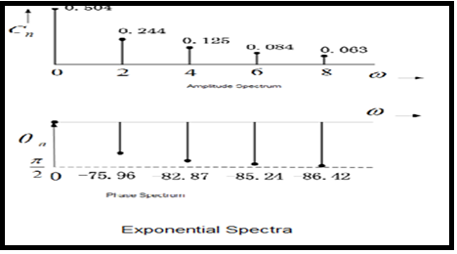

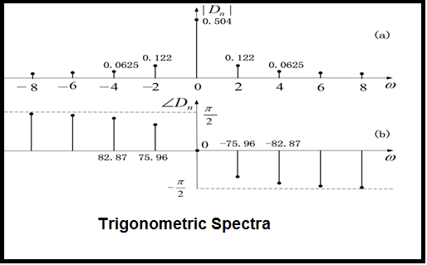
What is the meaning of the negative frequency?
In the later graphical representation we see that spectrum has integer values at n and integer values. The negative frequency is a mathematical tool, not physical . But the component of the positive frequency and the negative frequency both of them form what is called real function. No mean to the positive one in absence of the negative one and vice versa.
The Importance of Signal Spectrum
There are many benefits we get from signal spectrum when applying Fourier transformation on signals. These benefits are:
- The ease of Finding Systems Responses
We need finding the responses of LTI systems, when we know their Impulse Responses. Then we can easily apply the Convolution process upon the signal and the corresponding Impulse response. This operation in time domain is so complicate, but when transferring the signal in the frequency domain we can do this operation as follows: Firstly represent both the impulse response and the signal into their frequency representation, and then do a simple multiplication. After all return the outcome to it is time domain. Then easily we can find the responses of LTI systems.
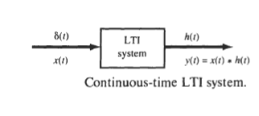
- The Convenient representation of signals
Only the LTI systems are the systems that when applying some periodic sinusoidal signals in their inputs, the responses also become sinusoidal outputs. This Characteristic is so good and required .Hence , we can represent any signal that is not in sinusoidal form in sinusoidal by applying Fourier Series technique . Then every signal can be represented as a sum of different weighted sinusoidal signals.
- Solving the problem of non-differentiable functions
There are some signals that are not continuous in some points (like square signals) ,and due to that it may not be differentiable at these points . To solve this problem we use Fourier series to represent these signals as continuous and differentiable sinusoidal signals.
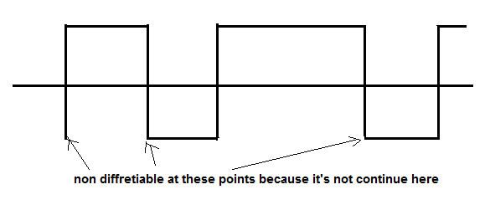
- Gaining most important transform ((Fourier Transform))
When LTI systems are excited by non-sinusoidal periodic signal, we can suppose it is excited by periodic signal with an infinite interval. Here we use Fourier Transform in the analysis .
- Remarking Communication Schemes
It's more convenient to represent the signals in the baseband and the signals in the band-pass by using Fourier transform and remark the big movement in the frequency from baseband to band pass.
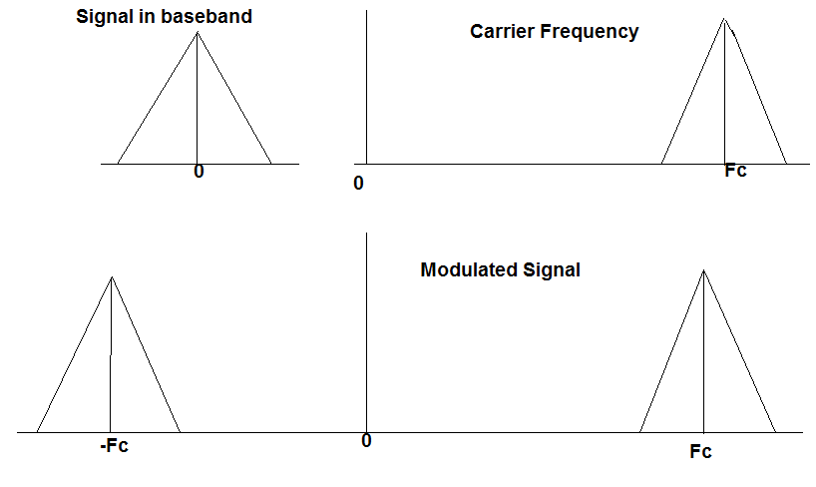
- Studying Different Modulation Schemes
Such as: Analog Modulation Schemes: to Represent the modulating signal, the carrier and the modulated signal .Fourier Transform is useful in Analog Modulation Schemes such as: Vestigial Side Band(VSB) , Single Side Band(SSB),double side band(DSB) and useful in Digital modulations. It may introduce a very good understanding to these schemes.
- Implementing Digital Filters
By the help of spectrum we can easily implement digital filters .Because the base of filters is to pass some components of the signal and stops other components from passing (rejecting process). This facility is so useful, because digital filters are the basis of building new DSP processors and they are commonplace and an essential element of everyday electronics such as radios, cell phones, and stereo receivers
- Understanding the main specification of signals
The signal that has a wide frequency band has the smallest time band and vice versa. The signal is band limited in frequency domain, becomes unlimited in the time domain, Delta function as an example.
Time Domin | Frequency Domain
periodic | Discrete
Discrete | periodic
- Define systems stability
Transfer the function that define the system in its equivalent Laplace Transform and notice the following:
If the system has only negative poles, that means this system is STABLE. if the system has at least one positive pole , that means this system is UN-STABLE. if the system have zero poles , that means this system is MAGINALLY STABLE.
- Power considerations
Defining the places that have a maximum power and the places where the power concentrates. From the spectrum only we can notice the power concentrations.
Application of DSP in Image Processing
Spatial Domain (I)
“Normal” image space in it Changes in pixel positions correspond to changes in the scene. Also Distances in This domain correspond to real distances.
Frequency Domain (F)
Changes in image position correspond to changes in the spatial frequency. This is the rate at which image intensity values are changing in the spatial domain image.
Image Processing in the
• Spatial Domain (I)
– Directly process the input image pixel array
• Frequency Domain (F)
– Transform the image to its frequency representation
– Perform image processing
– Compute inverse transform back to the spatial domain
Frequencies in an Image
• Any spatial or temporal signal has an equivalent frequency representation
• What do frequencies mean in an image ? the meaning is : High frequencies correspond to pixel values that change rapidly across the image (e.g. text, texture, leaves, etc.)
– Strong low frequency components correspond to large scale features in the image (e.g. a single, homogenous object that dominates the image)
• We will investigate Fourier transformations to obtain frequency representations of an image.
The Fourier Transform
Functions that are NOT periodic BUT with finite area under the curve can be expressed as the integral of sines and/or cosines multiplied by a weight function.The FT transforms can be easily extended to 2 (and n dimensions)
The Fourier transform for f(x) exists if:
(1) f(x) is piecewise continuous on every finite interval
(2) f(x) is absolutely integral.

The Discrete Fourier Transform
Since we are dealing with images, we will be more interested in the discrete Fourier Transform.
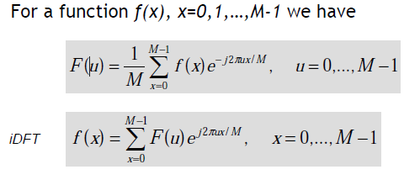
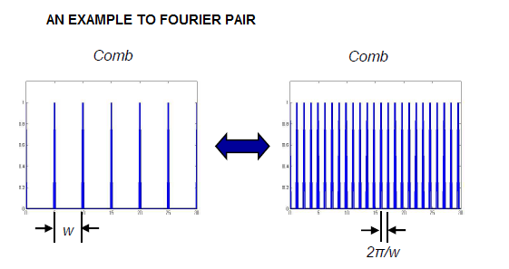
Sampling
Sampling is equivalent to multiplying with a comb filter in the spatial domain• This corresponds to convolving with a comb filter in the frequency domain
• Fine sampling in spatial → spread out filter in the frequency domain
• Coarse sampling in spatial → Close filter in the frequency domain
Aliasing
For an image sampled spatially, the shortest “wavelength” that be represented is 2 pixels
• When a signal is under-sampled, aliasing can result
• Aliasing is when a high frequency signal masquerades as a lower frequency signal
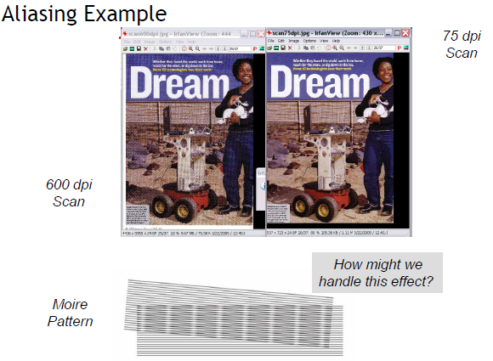
Filtering Example
Smooth an Image with a Gaussian Kernel
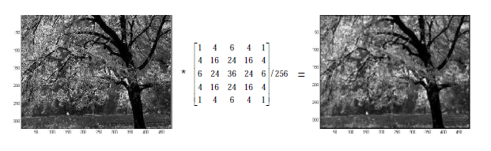
Traditionally, we would just convolve the image with the Gaussian kernel.
Instead, we will perform multiplication in the frequency domain to achieve the same effect
Filtering Example
Smooth an Image with a Gaussian Kernel
- Multiply the input image by (-1)x+y to center the transform
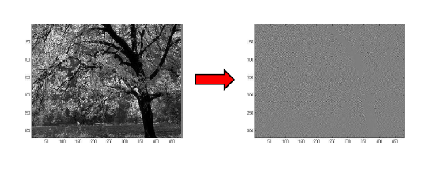
Compute the DFT F(u,v) of the resulting image(2)

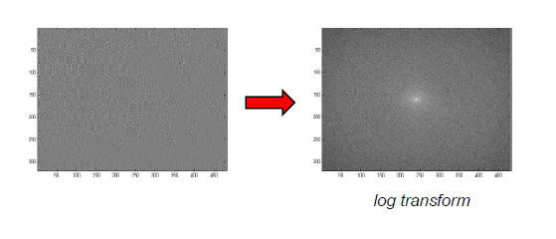

3. Multiply F(u,v) by a filter G(u,v)
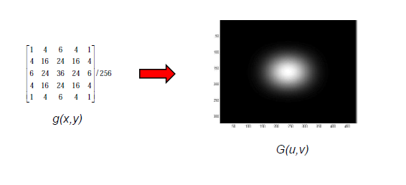

Multiply F(u,v) by a filter G(u,v) (3)

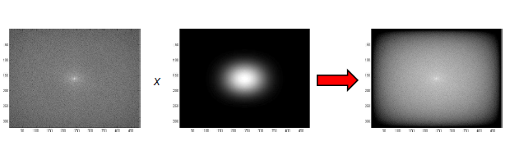
) Compute the inverse DFT transform h*(x,y)4 )
Obtain the real part h(x,y) of above step. ( 5)
(6) Multiply the result by (-1)^(x+y)
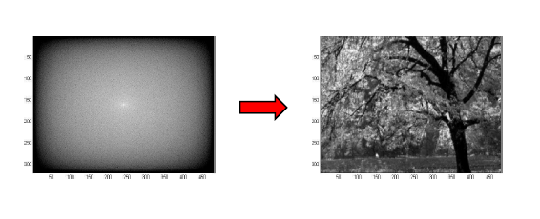

For Comparison

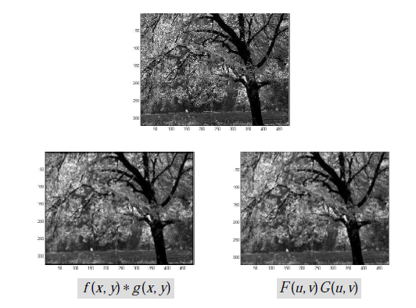

Conclusion

Images have both spatial and frequency representations. But, generally we use the DFT to obtain the latter.
• High texture results in high frequency components, while solid, homogenous objects correspond to low frequency components.
• Aliasing is when high frequency components masquerade as low frequency ones, and can result from improper image sampling.
• The effect can be eliminated by filtering out high frequency components of the signal .
• Convolution and multiplication are duals in the spatial/frequency domains .
• Although multiplication is MUCH more efficient than convolution, there is a high cost in computing the DFT and iDFT
• As such, most convolutions are carried out in the spatial domain (unless the kernel is sufficiently large)

